Software Requirements Specification

for

Speech Emotion Recognition

**Version 1.0 approved**

**Prepared by 20CE117, 20CE118, 20CE120, 20CE135, 20CE136**

**Made by: Dhruv Puvar, Khushi Ranpariya, Achyut Krishna Sai, Virti, Harvi Sheth**

**CSPIT-CE**

**02-01-2**

**Table of Content**

**Revision History I**

**1.** **Introduction** [**1**](https://docs.google.com/document/d/1XcAhdoYBQhnKiz6H2N2w44Q1ZP21ZV7u/edit#heading=h.3o7alnk)

1.1 Objective [1](https://docs.google.com/document/d/1XcAhdoYBQhnKiz6H2N2w44Q1ZP21ZV7u/edit#heading=h.23ckvvd)

1.2 Document Conventions [1](https://docs.google.com/document/d/1XcAhdoYBQhnKiz6H2N2w44Q1ZP21ZV7u/edit#heading=h.ihv636)

1.3 Intended Audience and Reading Suggestions [1](https://docs.google.com/document/d/1XcAhdoYBQhnKiz6H2N2w44Q1ZP21ZV7u/edit#heading=h.32hioqz)

1.4   Project Scope [1](https://docs.google.com/document/d/1XcAhdoYBQhnKiz6H2N2w44Q1ZP21ZV7u/edit#heading=h.1hmsyys)

1.5 References [2](https://docs.google.com/document/d/1XcAhdoYBQhnKiz6H2N2w44Q1ZP21ZV7u/edit#heading=h.41mghml)

**2.** **Overall Description** [**2**](https://docs.google.com/document/d/1XcAhdoYBQhnKiz6H2N2w44Q1ZP21ZV7u/edit#heading=h.2grqrue)

2.1 Product Perspective [2](https://docs.google.com/document/d/1XcAhdoYBQhnKiz6H2N2w44Q1ZP21ZV7u/edit#heading=h.vx1227)

2.2 Product Features [2](https://docs.google.com/document/d/1XcAhdoYBQhnKiz6H2N2w44Q1ZP21ZV7u/edit#heading=h.3fwokq0)

2.3 User Classes and Characteristics [2](https://docs.google.com/document/d/1XcAhdoYBQhnKiz6H2N2w44Q1ZP21ZV7u/edit#heading=h.1v1yuxt)

2.4 Operating Environment [2](https://docs.google.com/document/d/1XcAhdoYBQhnKiz6H2N2w44Q1ZP21ZV7u/edit#heading=h.4f1mdlm)

2.5 Design and Implementation Constraints [3](https://docs.google.com/document/d/1XcAhdoYBQhnKiz6H2N2w44Q1ZP21ZV7u/edit#heading=h.2u6wntf)

2.6 User Documentation [3](https://docs.google.com/document/d/1XcAhdoYBQhnKiz6H2N2w44Q1ZP21ZV7u/edit#heading=h.19c6y18)

2.7 Assumptions and Dependencies [3](https://docs.google.com/document/d/1XcAhdoYBQhnKiz6H2N2w44Q1ZP21ZV7u/edit#heading=h.3tbugp1)

**3.** **System Features** [**3**](https://docs.google.com/document/d/1XcAhdoYBQhnKiz6H2N2w44Q1ZP21ZV7u/edit#heading=h.28h4qwu)

3.1 System Feature [3](https://docs.google.com/document/d/1XcAhdoYBQhnKiz6H2N2w44Q1ZP21ZV7u/edit#heading=h.nmf14n)

**4.** **External Interface Requirements** [**4**](https://docs.google.com/document/d/1XcAhdoYBQhnKiz6H2N2w44Q1ZP21ZV7u/edit#heading=h.2jxsxqh)

4.1 User Interfaces [4](https://docs.google.com/document/d/1XcAhdoYBQhnKiz6H2N2w44Q1ZP21ZV7u/edit#heading=h.z337ya)

4.2 Hardware Interfaces [5](https://docs.google.com/document/d/1XcAhdoYBQhnKiz6H2N2w44Q1ZP21ZV7u/edit#heading=h.37m2jsg)

4.3 Software Interfaces [5](https://docs.google.com/document/d/1XcAhdoYBQhnKiz6H2N2w44Q1ZP21ZV7u/edit#heading=h.1mrcu09)

4.4 Communications Interfaces [5](https://docs.google.com/document/d/1XcAhdoYBQhnKiz6H2N2w44Q1ZP21ZV7u/edit#heading=h.46r0co2)

**5.** **Other Nonfunctional Requirements** [**5**](https://docs.google.com/document/d/1XcAhdoYBQhnKiz6H2N2w44Q1ZP21ZV7u/edit#heading=h.2lwamvv)

5.1 Performance Requirements [5](https://docs.google.com/document/d/1XcAhdoYBQhnKiz6H2N2w44Q1ZP21ZV7u/edit#heading=h.1ci93xb)

5.2 Safety Requirements [6](https://docs.google.com/document/d/1XcAhdoYBQhnKiz6H2N2w44Q1ZP21ZV7u/edit#heading=h.111kx3o)

5.3 Security Requirements [6](https://docs.google.com/document/d/1XcAhdoYBQhnKiz6H2N2w44Q1ZP21ZV7u/edit#heading=h.3l18frh)

5.4 Software Quality Attributes [6](https://docs.google.com/document/d/1XcAhdoYBQhnKiz6H2N2w44Q1ZP21ZV7u/edit#heading=h.206ipza)

**6.** **Other Requirements** [**6**](https://docs.google.com/document/d/1XcAhdoYBQhnKiz6H2N2w44Q1ZP21ZV7u/edit#heading=h.4k668n3)

**Appendix A: Glossary** [**6**](https://docs.google.com/document/d/1XcAhdoYBQhnKiz6H2N2w44Q1ZP21ZV7u/edit#heading=h.2zbgiuw)

**Appendix B: Analysis Models** [**7**](https://docs.google.com/document/d/1XcAhdoYBQhnKiz6H2N2w44Q1ZP21ZV7u/edit#heading=h.1egqt2p)

**Appendix C: Issues List** [**7**](https://docs.google.com/document/d/1XcAhdoYBQhnKiz6H2N2w44Q1ZP21ZV7u/edit#heading=h.3ygebqi)

**Revision History**

|  |  |  |  |
| --- | --- | --- | --- |
| **Name** | **Date** | **Reason For Changes** | **Version** |
|  |  |  |  |
|  |  |  |  |
|  |  |  |  |
|  |  |  |  |
|  |  |  |  |

# 1) Introduction

## 1.1 Introduction

As human beings, speech is amongst the most natural ways to express ourselves. We depend so much on it, emotions play a vital role in communication, the detection and analysis of the same is of vital importance in today’s digital world of remote communication.

Speech Emotion Recognition System, abbreviated as SER System, is the act of attempting to recognize human emotion and affective states from speech. This is capitalizing on the fact that voice often reflects underlying emotion through tone and pitch. The speech emotion recognition system uses audio data. It takes a part of speech as input and then determines what emotions the speaker is speaking.

* **1.2 Document Conventions**

The requirements of the project are detailed below. Also identifies the function and non-functional requirements of the project. All in all, this document is used for how users or admin interact with the system and understand how the mechanism works without any problems.

We have chosen fonts and highlighted certain information which will be reader friendly.

## 1.3 Intended Audience and Reading Suggestions

The software requirement specification (SRS) document is written for a general audience.

This document need not be read sequentially; users are encouraged to jump to any section they find relevant. Below is a brief overview of each part of the document...

# 1.4 Project Scope

SER system will be able to perform emotion recognition from audio. Determination of a user’s emotional state with voice analysis plays a fundamental part in human-machine interaction (HMI) systems.

Soo, it has its merits on both

application areas as well as research areas. This project could be helpful for a variety of application areas like Smart home appliances and interactive voice based-assistant (Examples: Amazon Alexa and Google Home) are ubiquitous these days or caller-agent conversation analysis or identifying customer emotions during the call as customer care-based call centers often have an automated voice control which might not please most of theirangry customers. Redirecting such calls to a human attendant will improve the service. with the call center, and there are many of the research areas that benefit from automating the emotion detection technique include psychology, psychiatry, and neuroscience...

# 2 Overall Description

## 2.1 Product Perspective

An emotion recognition system can detect the emotion condition of a person either from his speech. In this scope, an audio-emotion recognition system requires to evaluate the emotion of a person from his speech alone.

* **2.2 Product features**

The software described in this SRS will be used to detect people's emotions. This project can be used in several areas that like to measure customer satisfaction in a marketing platform, helping advertisers to sell products more effectively.

* **2.3 User Classes and Characteristics**

The person who will use this software must have basic computer knowledge. The user must read the user manual and apply it.

* **2.4 Operating Environment**.

While developing the project, we have decided to use JupyterLab. JupyterLab is an agile open-source software

* + - * *client/server system*
      * *Localhost Apache server system*
      * *Operating system: Windows, MacOS, Linux*
      * *platform: HTML/ JavaScript /CSS / JupyterLab*

## 2.6 Design and Implementation Constraints

The audio format must be waw. And the audio files must have a maximum duration of 10 seconds.

For the software to run stable, the inputs must provide certain conditions.

These conditions are listed below:

Audio quality,

No background noise,

Audio should be clear.

## 2.7 User Documentation

# 3 System Features

## Profile Management Use Case

* + - Use Case:

● Login

● Sign Up

● Validation

● Exit

**Brief Description:**

When the user and admin first enter the system, they come across the authentication menu. Admin and user can use the functions that are Sign Up, Login and Exit.

Initial Step by Step Description:

1. Users and admin must login the system.

2. If the username and password is invalid that should re-login.

3. Users and admin can exit from the system.

**User Use Case**

Use Case:

● Upload Content

● Get Result

● Content Information

● Add

● Show

**Brief Description:**

Users are able to use the following function: Upload Content, Get Result, also Add and Show in Content Information and see all uploaded content in the system.

**Initial Step by Step Description:**

1. User selects Upload Content; the system will wait for you to upload files from your computer. Also, it accepts some format (mp4, waw).

2. After users have uploaded content, they should enter, add and view content's information.

3. Get Result; after users have uploaded or recorded content, the system will give you the result as an emotion.

**Admin Use Case**

Use Case:

● List Content

● System Train

● System Test

● Analyse

● Show Content

● Content Information

● Add

● Edit

● Delete

**Brief Description**:

The admin is authorized to intervene in the system. Figure IV is an admin use case diagram that explains admin's privileges.

Initial Step by Step Description:

1. Admin can see all uploaded content in the system.

2. Admin can train or test the system using these contents.

3. Admin can analyze data statistics in content. (E.g. Female/Male ratio, age range)

4. Admin can view content and edited, deleted and added content's information.

3.1.1 **Stimulus/Response Sequences**

AUTHENTICATION PAGE

Stimulus: user click on profile icon.

Response: signup/login option is been displayed.

Stimulus: user enter user id and password.

Response: user id and password are validated.

Home page

Stimulus: user click on get stared button

Response: Speech emotion recognition system is been displayed

User page

Stimulus: user upload audio file and click analysis button

Response: bright the emoticon of emotion that is depicted from audio file

Admin page

Stimulus: admin click on train button.

Response: can see or test the system using the audio containt’s.

# 4 External Interface Requirements

## 4.1 User Interfaces

Our software will be able to work actively on all platforms with python 3.6 installed. What the user can do in the interface is listed below:

* + Can externally add files,
  + Should be, contact information can be specified,
  + Should comment on the emotion of the video.

Unlike the user, the administrator will be able to make the features listed below.

1. Test and train the system,

2. Can comment on files uploaded by the user,

3. Will be able to access and edit the information uploaded by the user

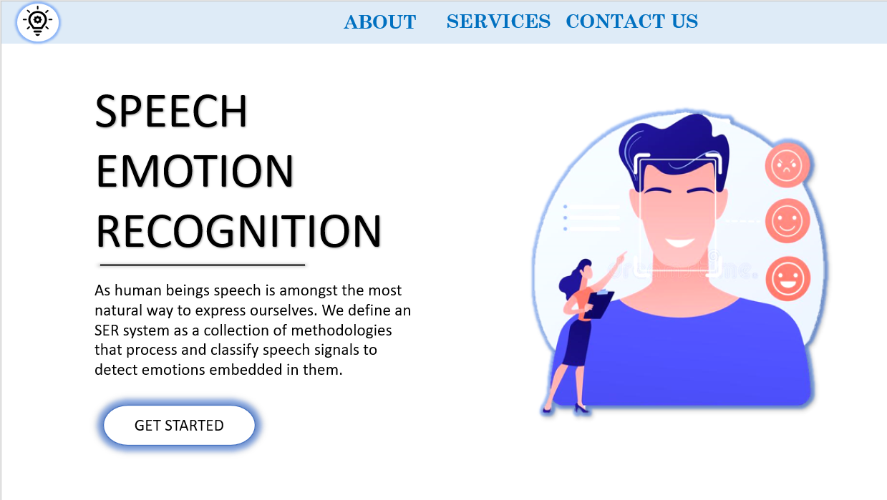

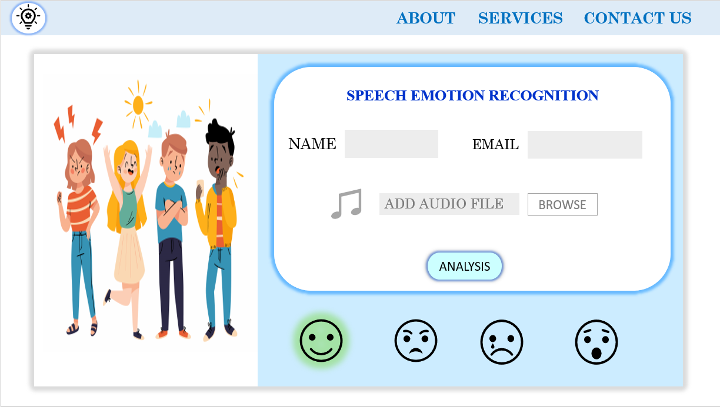

* ***4.2* Hardware Interfaces**

The computer to be used must have microphone input for voice recordings.

*Browser which supports CSS, HTML, JavaScript*

* **4.3 Software Interfaces**

The computer to be used must have the libraries attached to python. Some of these libraries

are librosa, openCV, keras, sklearn, etc.

|  |  |
| --- | --- |
| ***Software used*** | ***Description*** |
| *Operating system* | *We have chosen Windows operating system for its best support and user-friendliness. but the project can run on both mac and Linux as well* |
| *Database* | *To save the audio records, we have chosen SQL+ database.* |
| *Visual studio code* | *To implement the website we have chosen HTML, CSS, JavaScript language for its more interactive support.* |
| Jupyter Lab | *To implement the website we have Chosen Jupyter Lab And language python* |

## 4.4 Communications Interfaces

This project supports all types of web browsers.

**5 Other Nonfunctional Requirements**

## 5.1 Performance Requirements

The minimum system requirements for the computer to be used are as follows:

1. Processors: Intel® Core™ i3 processor or AMD Phenom X4

2. Disk space: 1 GB

3. Operating systems: Linux, macOS, and Windows 7 or later

4. Python versions: 3.6.X or higher

5. Included development tools: Anaconda

6. Compatible tools: Microsoft Visual Studio, PyCharm, Spyder or VSCode.

* **5.2 Safety Requirements**

System reliability will improve as long as the sound quality is good and the person's voice is clearly audible. Since the size and type of the file to be uploaded is limited, no system crashes will be allowed.

* .**5.3 Security Requirements**

In order to improve the software, we will be stored input data to the system and will use these data to develop this system. This data will be used to increase stability. Therefore, before receiving the data from the user, a pre-acceptance text will be indicated that the data will only be used for system improvement.

## 5.4 Software Quality Attributes

The system will work on all operating systems. In order to increase the stability of the software, the training and test files of the software will be updated once a month by the administrator. Since the developed application is a user-oriented project, it should provide simple usage to the user. Therefore, the interface we will prepare will be understandable and user-oriented.

* ***AVAILABILITY:*** *Our Project website is available 24*7.*
* ***CORRECTNESS:*** *The Python code will have more than or equal 72.40%* accuracy
* ***MAINTAINABILITY:***project website will be updated and *maintained* once a month by the administrator
* ***USABILITY:*** *the web application is very user friendly and easy to use and anyone with basic knowledge of computers as use our web application*

# Other Requirements

1. The computer to be used must have microphone input for voice recordings.
2. The computer to be used must have the libraries attached to python. Some of these libraries

are librosa, sklearn.

1. There is an internet connection required to run this software.

*References*

[*https://krazytech.com/projects/sample-software-requirements-specificationsrs-report-airline-database*](https://krazytech.com/projects/sample-software-requirements-specificationsrs-report-airline-database)